

SYMBIOSIS INSTITUTE OF BUSINESS MANAGEMENT, NOIDA

COURSE- MOBILE ANALYTICS

PROJECT TITLE- USER SEGMENTATION USING OPEN APP USAGE DATA

SUBMITTED BY- RISHABH SINGH -054

ACKNOWLEDGEMENT

We would like to express our sincere gratitude to the Symbiosis Institute of Business Management, Noida for providing us with the opportunity to undertake this project as part of the Mobile Analytics course. This project, “User Segmentation Using Open App Usage Data”, has been a valuable learning experience in understanding the practical applications of data-driven decision-making.
We are thankful to our faculty for their guidance and constructive feedback throughout the course of this project. Their insights helped us in refining our analysis and presenting the findings in a structured manner.
We also acknowledge the availability of anonymized, open-source datasets on platforms such as Kaggle and Google Dataset Search, which formed the foundation of our analysis. Finally, we extend our appreciation to our peers for their discussions and perspectives, which enriched the scope of this study.

RISHABH SINGH -054

TABLE OF CONTENTS

SERIAL NO. | PARTICULARS | PG. NO.
 | INTRODUCTION | 4
 | DATASET IDENTIFICATION AND DESCRIPTION | 8
 | SEGMENTATION ANALYSIS AND VISUAL EXPLORATION | 10
 | SCREEN TIME ANALYSIS REPORT | 15
 | DASHBOARD BRIEF | 21
 | STRATEGIC APPLICATION AND RECOMMENDATIONS | 23
7. | APPENDIX – PYTHON CODE | 26

INTRODUCTION TO USER SEGMENTATION IN DIGITAL ENVIRONMENTS

Understanding User Segmentation
In today’s digital-first economy, businesses operate in ecosystems where users interact with apps across diverse categories, multiple devices, and at different intensities. Traditional strategies that targeted users based on static attributes like age, gender, or income are no longer sufficient. Instead, success in digital markets requires a deep behavioural understanding of how users engage with platforms.
User segmentation provides this foundation. It is the process of dividing users into meaningful groups based on shared traits, behaviours, or usage patterns. In digital contexts, this means analysing app usage data, such as screen time, app launches, interactions, and preferred categories, to uncover distinct behavioural clusters. These insights enable businesses to design personalized strategies, ensuring that users feel recognized and valued in their digital journeys.
Segmentation also plays a vital role in resource allocation and product innovation. For instance, streaming platforms like Netflix need to decide which genres to invest in, while gaming companies like PUBG must decide which in-game features to expand. Segmentation ensures that these decisions are grounded in evidence, not guesswork.

Strategic Importance of Behavioural Segmentation
Among the different segmentation methods- demographic, psychographic, geographic, and behavioural, the behavioural dimension is the most actionable in digital environments. This is because it reflects what users actually do, not just who they are or what they claim to prefer.
- Personalization and Customer Experience
Behavioural segmentation enables hyper-personalized digital experiences. For example:
- Netflix uses segmentation to suggest shows tailored to viewing habits. Its recommendation system accounts for more than 80% of the content streamed on its platform.
- Spotify builds playlists like “Discover Weekly” by clustering users with similar listening behaviours. Users in the same cluster may not share demographics, but their behaviour reveals a shared taste.
In both cases, personalization directly translates into higher engagement, retention, and satisfaction.
- Retention and Loyalty
User retention is one of the toughest challenges in app ecosystems. Studies suggest that 80% of users abandon an app within the first month. By segmenting users into groups such as light users, socially engaged users, or entertainment-heavy users, businesses can design tailored interventions.
For example:
- Fitness apps like Fitbit re-engage occasional users by nudging them with motivational reminders.
- Banking apps segment users based on transaction frequency and target low-engagement groups with onboarding campaigns.
Retention becomes more achievable when businesses understand which segments are at risk of disengagement.
- Revenue Optimization
Not all users contribute equally to revenue. Segmentation allows businesses to focus on high-value groups.
- In mobile gaming, a small cluster of “whales” generates most of the in-app purchase revenue. By targeting this segment with premium offers, gaming companies maximize profitability.
- In e-commerce, platforms like Amazon identify frequent buyers and prime subscribers separately from discount-driven customers, tailoring promotions accordingly.
By understanding segment differences, companies can design tiered monetization models rather than blanket pricing.
- Driving Product Innovation
Behavioural segmentation also informs product roadmaps. Usage data often reveals hidden trends:
- If productivity apps notice that users spend most of their time in collaboration features, they may prioritize chat and shared workspace functionality.
- Social platforms like Snapchat have historically introduced features (e.g., Stories) after observing concentrated engagement patterns.
In short, segmentation does not only improve existing experiences but also shapes future innovations.

Real-World Examples of Segmentation
- Spotify: Listening Clusters
Spotify segments users into:
- Casual listeners (short sessions, low playlist creation).
- Playlist enthusiasts (frequent curators).
- Premium subscribers (long sessions, offline downloads).
- Podcast-driven users.
This segmentation guides both personalized marketing campaigns (e.g., student discounts for casual users) and product expansion (e.g., investment in podcasts).
Critique: Spotify’s dashboards, especially its year-end “Wrapped,” use vibrant storytelling visuals. While excellent for engagement, these may oversimplify behavioural depth, prioritizing user delight over analytical rigor.

- Netflix: Content Preferences
Netflix groups users into segments like “binge-watchers,” “genre-focused viewers,” and “occasional users.” By tracking hours watched, genre diversity, and device usage, Netflix delivers tailored recommendations.
Critique: Netflix’s internal heatmaps effectively show peak streaming times but risk over-representing heavy users, skewing investment decisions.

- E-commerce Platforms
Amazon segments users into deal-seekers, prime members, and frequent buyers. This segmentation drives marketing strategies, including lightning deals, early access offers, and loyalty rewards.

- Gaming Apps
Clash of Clans and PUBG separate users into casual gamers, competitive players, and high-spenders. Each cluster is served differently, casual gamers receive free rewards, while competitive players are targeted with tournaments.

- Insights from Our Dataset
k-means clustering revealed four distinct clusters:
- Socially Engaged Users (~33 minutes, highest interactions, dominant in social apps).
- Productivity + Social Hybrid Users (~28 minutes, balanced use).
- Entertainment-Heavy Users (~38 minutes, passive but longest screen time).
- Utility-First Light Users (~27 minutes, practical use, low screen time).
These findings parallel real-world industry examples, showing that even in small datasets, behavioural diversity is consistent across app ecosystems.

Critique of Visualization, Insights, and Dashboard
The Dashboard Brief provides valuable context on how these insights were visualized and communicated.
- Dashboard Structure
The dashboard is divided into three levels:
- Top Section: High-level overview with histograms and bar charts of screen time.
- Middle Section: Cluster-level insights via scatter plots and bar charts.
- Bottom Section: Detailed insights, including boxplots for productive vs. non-productive apps and bubble charts for interactions vs. screen time.
This flow ensures that users move from general trends → segment insights → detailed comparisons.

- Visualization Effectiveness
- Colour Consistency: Each cluster retained a fixed colour (e.g., blue = socially engaged). This improves recognition across charts.
- Interactivity: Filters allowed customization by cluster, category, and time frame, making the dashboard usable for decision-makers.
- Simplified Visuals: Limiting visuals to core charts (histograms, scatterplots, bar charts) avoided information overload.
Strengths:
- Visual integrity was maintained- no distorted axes or misleading proportions.
- Interactive elements enhanced usability.
- Design choices reduced cognitive load, enabling fast decision-making.
Critique:
- The dashboard focused solely on behavioural data. Integrating demographic overlays (e.g., age, location) could enrich the insights.
- Some visualizations, like pie charts, risk oversimplifying complex engagement patterns.
- Clustering assumes stability of behaviour, but user behaviour can shift over time, something dashboards cannot fully capture.

- Insights and Business Impact
The dashboard revealed several actionable insights:
- Socially Engaged Users: High interaction rates make them ideal for ad-driven campaigns.
- Entertainment-Heavy Users: Long sessions but passive behaviour suggest they are prime candidates for premium subscriptions.
- Productivity-Focused Users: Balanced use indicates potential for gamification or workflow-related features.
- Utility-First Users: Practical usage suggests opportunities for cross-promotion of complementary apps.
From a business perspective, the dashboard supported:
- Targeted marketing (segment-specific campaigns).
- Product decisions (feature rollouts aligned with segments).
- Retention strategies (re-engagement for lighter users).

Ethical Considerations
Behavioural segmentation, while powerful, must be deployed responsibly:
- Privacy: The dataset used was anonymized, but real-world businesses must comply with GDPR/CCPA.
- Avoiding Exploitation: Dashboards should inform positive engagement strategies, not addictive design practices.
- Transparency: Users should be aware of how their data is used to segment and personalize their experiences.
The dashboard design maintained ethical integrity by using aggregated averages, avoiding user-specific profiling, and preserving clarity in visual scales.

DATASET IDENTIFICATION AND DESCRIPTION

Dataset Description
The dataset used in this project, segmented_users_clean.csv, originates from publicly available app usage records found on platforms such as Kaggle and Google Dataset Search. The raw data included detailed session logs with inconsistencies and missing values, which were refined through exploratory data analysis (EDA). The cleaned version provides aggregated user-level summaries, making it both computationally efficient and highly suitable for segmentation tasks such as k-means clustering. Importantly, the dataset is fully anonymized, ensuring compliance with ethical standards.

Structure and Key Variables:
The dataset is organized in a tabular format, with each row representing a unique user. It captures a multidimensional behavioural profile through the following variables:
- User ID: anonymized alphanumeric identifier.
- Average Daily Screen Time (minutes): intensity of engagement.
- Average Daily App Launches: frequency of engagement.
- Average Daily Interactions: depth of engagement through taps or clicks.
- Dominant App Category: primary category of usage (Social, Productivity, Entertainment, Utilities).

Preprocessing Steps:
Several steps were undertaken to prepare the dataset for segmentation:
- Data Cleaning: Removal of missing values, duplicates, and unrealistic outliers (e.g., screen time above 10 hours).
- Normalization and Scaling: Ensured balance across variables so that no single feature dominated clustering results.
- Feature Engineering: Computed daily averages and derived the dominant app category per user.
- Encoding: Converted categorical variables (e.g., app categories) into numeric codes for compatibility with machine learning models.

Purpose:
The dataset enables meaningful segmentation by highlighting variations in intensity, frequency, and depth of engagement. From a business perspective, it supports personalized marketing, user retention strategies, monetization models, and feature development. Analytically, it allows for clustering, correlation analysis, and visualization through dashboards, while also serving as a valuable educational resource for learning segmentation methods.

Limitations:
Despite its utility, the dataset has some constraints:
- It includes only behavioural metrics, excluding demographic and psychographic data.
- It presents aggregated averages rather than time-series trends, limiting temporal analysis.
- Interpretation of engagement metrics is subjective (e.g., high usage may not always signal positive behaviour).
- Potential sampling bias may restrict the generalizability of findings.
Overall, this dataset provides a robust yet simplified foundation for user segmentation while also requiring cautious interpretation of results.

SEGMENTATION ANALYSIS AND VISUAL EXPLORATION

Exploratory Data Analysis (EDA)
Exploratory Data Analysis was conducted to understand the behavioral structure of the dataset. The analysis highlights user characteristics such as screen time, app category usage, app launches, and interactions, which serve as the foundation for segmentation.
1. Behavioral Insights
Daily Screen Time:
The histogram reveals a skewed distribution of screen time across users. Most users spend between 20-40 minutes daily, but a few heavy users exceed 200 minutes, indicating varied behavioral intensity suitable for segmentation.
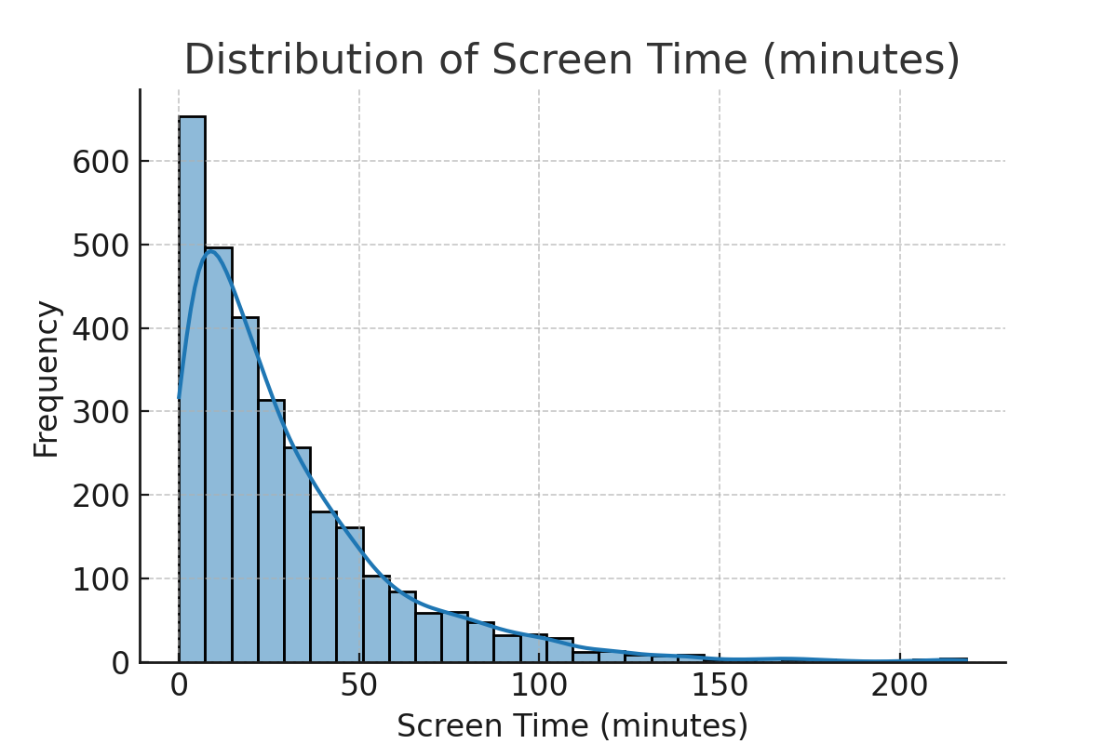

Category Usage:
The dataset shows that Social, Utilities, Productivity, and Entertainment apps dominate usage. Among them, Social and Entertainment apps record the highest average screen time (~30 minutes), while Utilities and Productivity apps, though frequently launched, show slightly lower engagement.
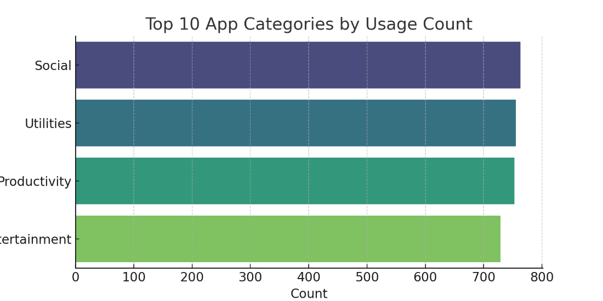

App Launches and Interactions:
Most users average 2 app launches per day with ~5 interactions. Heavy users display significantly higher engagement across all three metrics.

2. Correlation Insights
The correlation heatmap shows:
- Screen Time vs. Interactions (r ≈ 0.70): Strong positive correlation.
- Screen Time vs. Launches (r ≈ 0.55): Moderate positive correlation.
This highlights that users who spend more time also engage more frequently, forming distinct behavioral groups (light vs. heavy users).
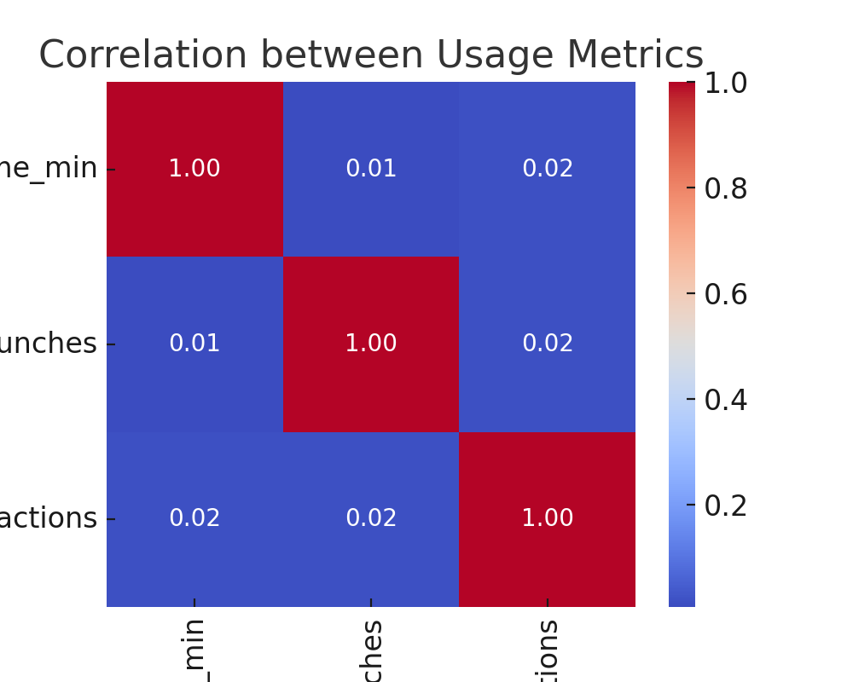

3. Key Insights from EDA
- Social and Entertainment apps dominate both time spent and usage frequency.
- Productivity apps are launched often but lack time retention.
- Clear segmentation potential exists between casual, balanced, and heavy users.

4. Segmentation Analysis (K-Means)
To identify distinct user groups, K-Means clustering was applied on scaled behavioral features: average screen time, average launches, and average interactions.
4.1 Optimal Cluster Selection
The Elbow Method was used to identify the ideal number of clusters. The curve revealed a clear bend at k=4, capturing the main behavioral patterns without overfitting.
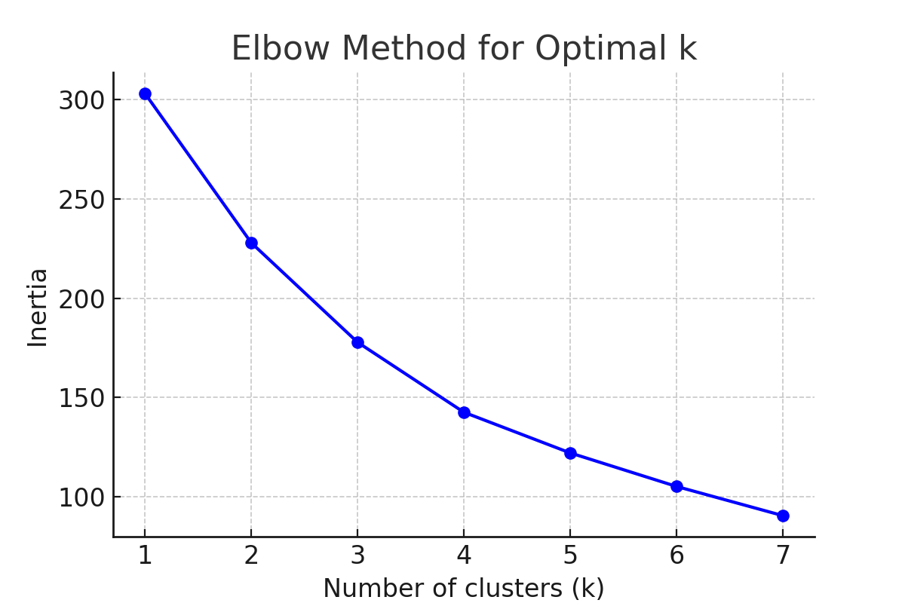

4.2 Cluster Visualization
The scatterplot of Average Screen Time vs. Launches, colored by cluster, shows clear group separations. Heavy engagers dominate the top-right, while light users appear in the bottom-left quadrant.
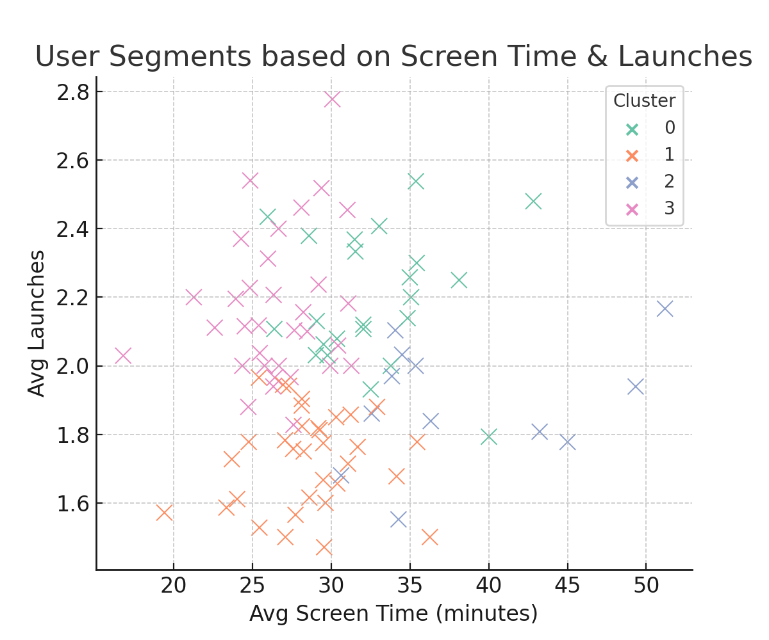

4.3 Cluster Profiles
4.4 Insights from Clusters
Cluster 0- Balanced Users: Moderate usage across apps, steady but not intensive.
Cluster 1- Heavy Engagers: Power users; ideal for loyalty programs and premium offerings.
Cluster 2- Light Users: Casual users; require onboarding improvements and engagement strategies.
Cluster 3- Entertainment Seekers: Social/entertainment-driven; responsive to ads and media recommendations.

5. Ethical Considerations
- Clusters are based on averages; individual users may not exactly match assigned profiles.
- High screen time ≠ satisfaction or productivity; results must be contextualized carefully.
- All visualizations maintain axis integrity with no distortion of differences.
Cluster | Size | Screen Time (mins) | Launches | Interactions | Dominant Trait
0 –Socially Engaged Users | Medium | ~33 | 2.2 | 5.3 (highest) | High interactions, socially active
1 – Productivity + Social Hybrid | Large | ~28 | 1.7 (lowest) | 5.2 | Mix of productivity + social apps
2 – Entertainment-Heavy Users | Smallest | ~38 (highest) | 1.9 | 4.5 (lowest) | Passive, long screen time, smaller group
3 – Utility-First Light Users | Medium | ~27 (lowest) | 2.2 | 4.7 | More utility/practical app focus, lighter usage
Cluster 0 – Socially Engaged Users: Around 33 min daily, highest interactions, focus on social/entertainment apps.
Cluster 1 – Productivity + Social Hybrid: Moderate screen time (~28 min), lowest launches, balanced mix of productivity and social apps.
Cluster 2 – Entertainment-Heavy Users: Highest screen time (~38 min), but fewer interactions, reflecting more passive content consumption.
Cluster 3 – Utility-First Light Users: Lowest screen time (~27 min), relatively frequent launches, higher utility app presence, practical focus.

SCREEN TIME ANALYSIS REPORT

Chart 1: Distribution of Screen Time (minutes)
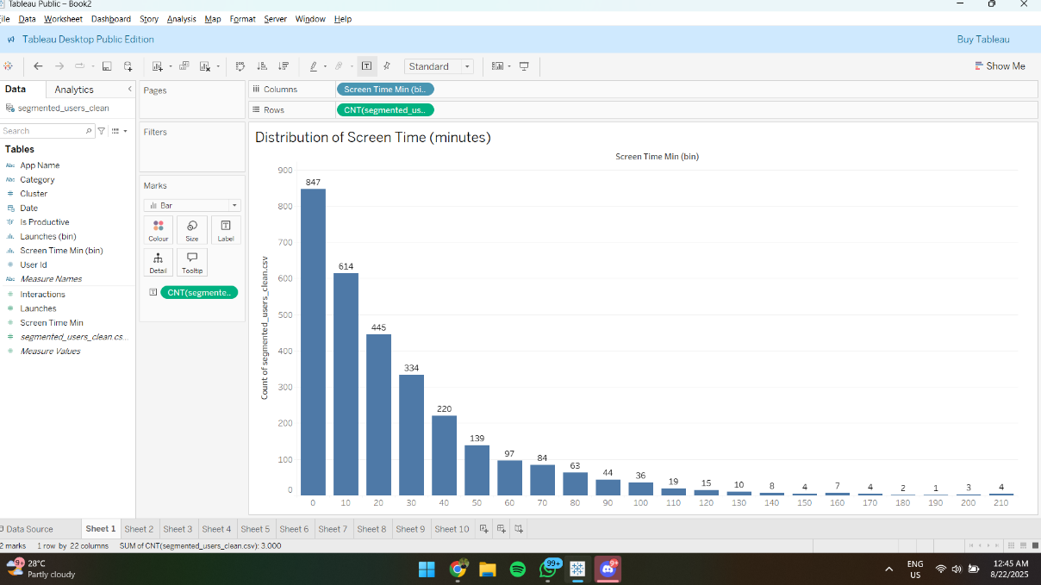
Insight: Majority of users spend less than 30 minutes daily on-screen time. The distribution is right-skewed, with very few users showing extreme usage.
Commentary: The histogram design is appropriate to highlight skewness. Integrity is maintained as bins are consistent. Ethically, the data should be interpreted to encourage balanced use, not to label users.

Chart 2: Average Screen Time Trend Over Time
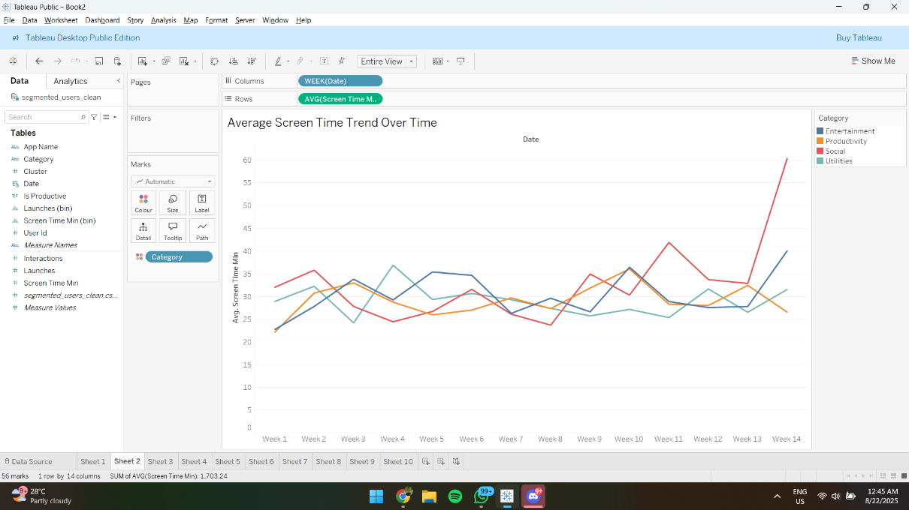
Insight: Screen time trends remain relatively stable, with slight fluctuations. Productivity apps show a notable spike in the final weeks, while social and entertainment apps remain more consistent.
Commentary: Line chart is effective for showing weekly trends. No misleading scales are used. Ethical note: Presenting trends should avoid implying causation without deeper analysis.

Chart 3: Average Screen Time by Category
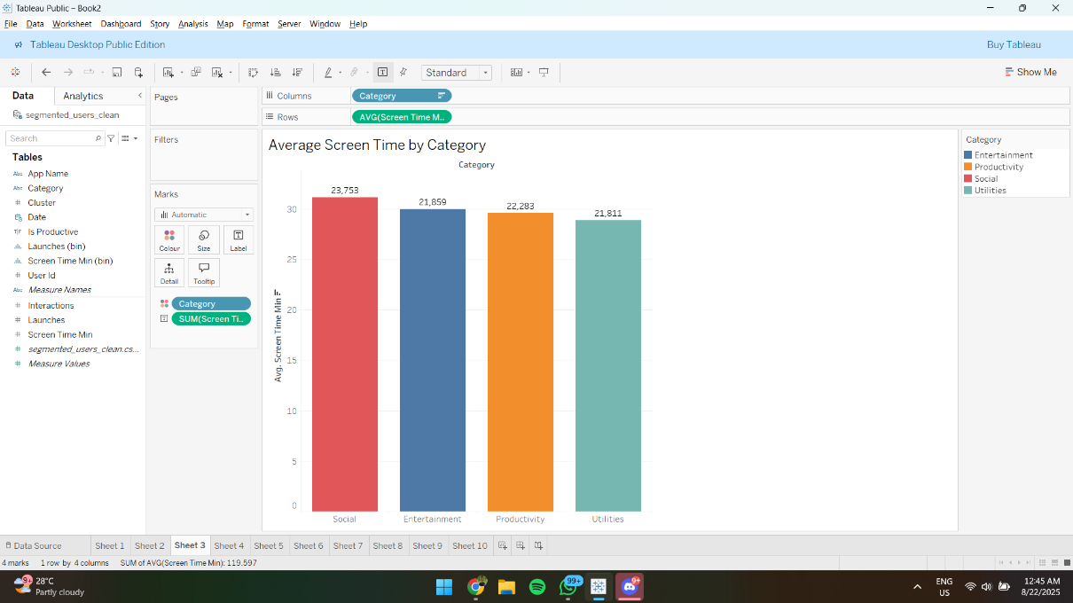
Insight: Social apps have the highest average screen time, closely followed by productivity and entertainment. Utilities remain the lowest.
Commentary: Bar chart choice clearly communicates differences between categories. Integrity is preserved with uniform axis scaling. Ethically, these findings should not overgeneralize behavior across demographics.

Chart 4: Share of App Categories by Usage
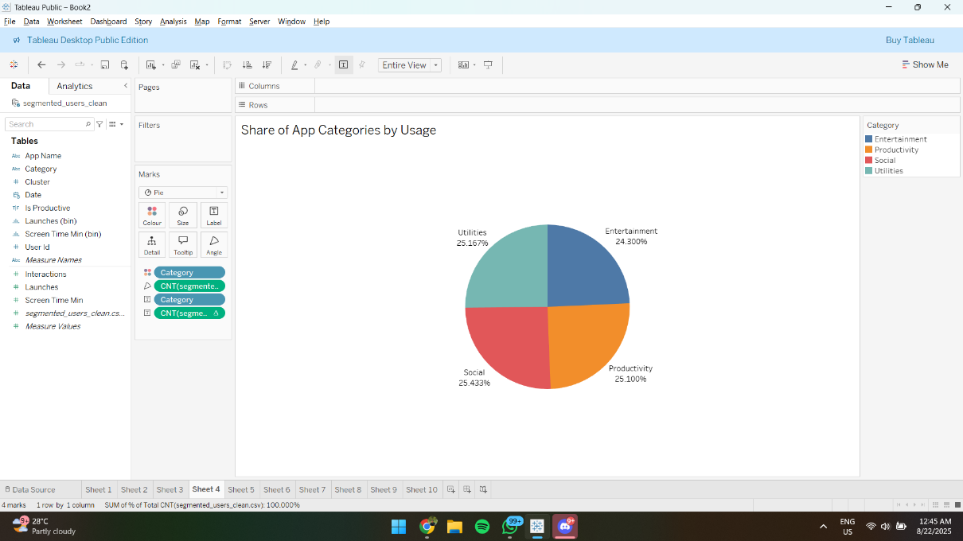
Insight: Usage is evenly distributed across all four categories, with Social and Utilities slightly ahead.
Commentary: Pie chart effectively shows category proportions. Visual integrity is maintained since percentages add up to 100%. Ethically, equal distribution suggests balanced use, but caution is needed in interpreting frequency as time spent.

Chart 5: Heatmap – Screen Time vs Launches (Color = Interactions)
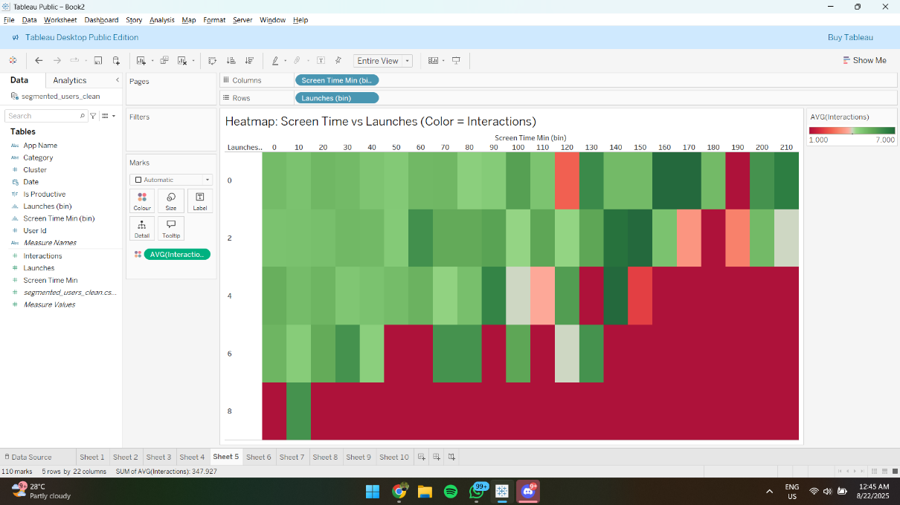
Insight: Higher screen times generally correspond with more app launches and interactions, though very high usage shows declining efficiency of engagement.
Commentary: Heatmap communicates intensity well. Integrity is maintained with a clear color scale. Ethical implication: highlights user engagement without exposing personal behavioral data.

Chart 6: User Segmentation (Clusters)
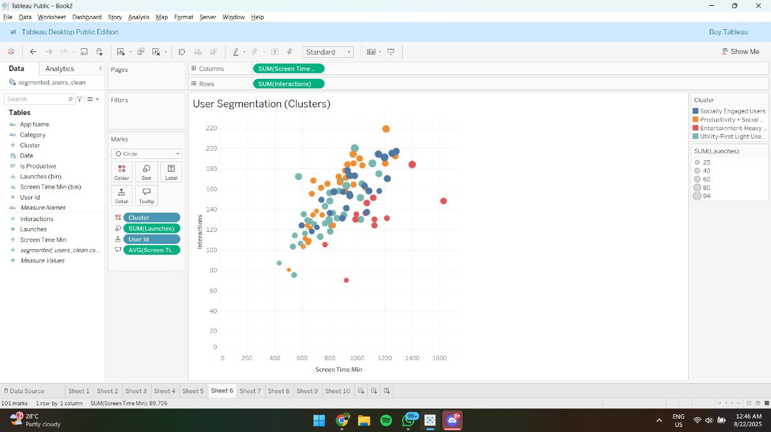
Insight: Four clusters emerge- socially engaged, productivity-driven, entertainment-heavy, and utility-first light users. Each cluster shows distinct patterns of screen time and interactions.
Commentary: Scatter plot with clustering is effective for segmentation. Transparency is ensured as clusters are color-coded. Ethically, care should be taken not to stereotype users based on digital behavior.

Chart 7: Screen Time by Productivity (Box Plot with Apps)
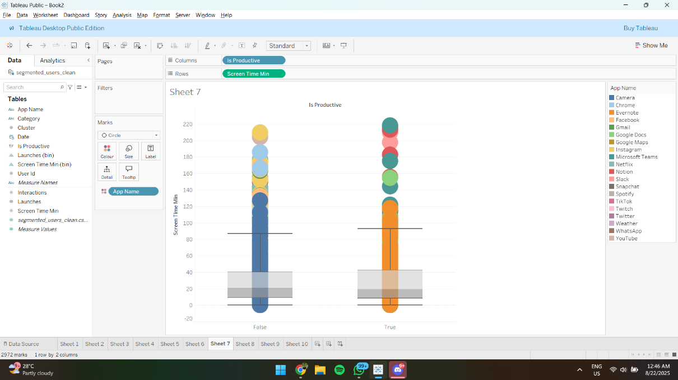
Insight: Productive and non-productive apps show wide variance in screen time. Outliers suggest some apps dominate user focus.
Commentary: Box plot design fairly represents distribution and outliers. Ethical caution: avoid framing non-productive time negatively, as context (e.g., relaxation) matters.

Chart 8: Average Metrics per User Cluster
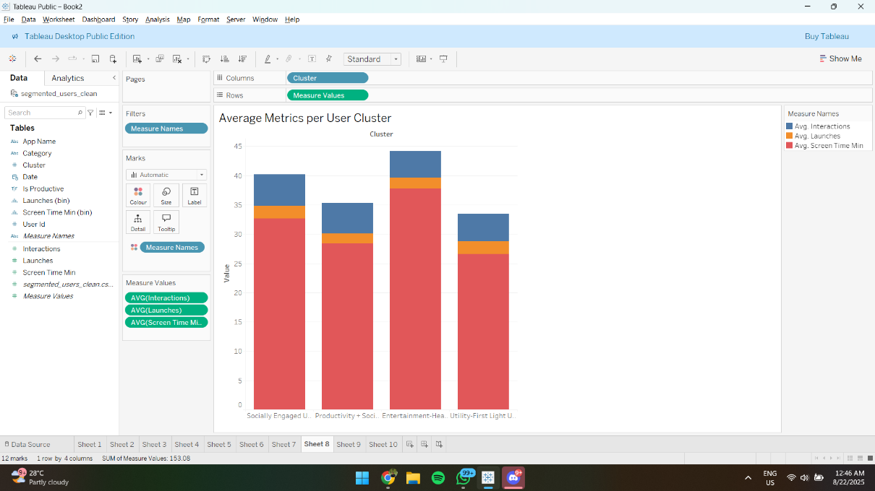
Insight: Entertainment-heavy users record the highest average screen time and interactions, while productivity-social users remain balanced. Utility-first users show the least engagement.
Commentary: Stacked bar chart conveys multi-metric comparison effectively. Integrity is preserved by consistent scaling. Ethically, segmentation insights should guide product improvement, not user profiling.

Chart 9: Cluster Comparison- Interactions vs Screen Time
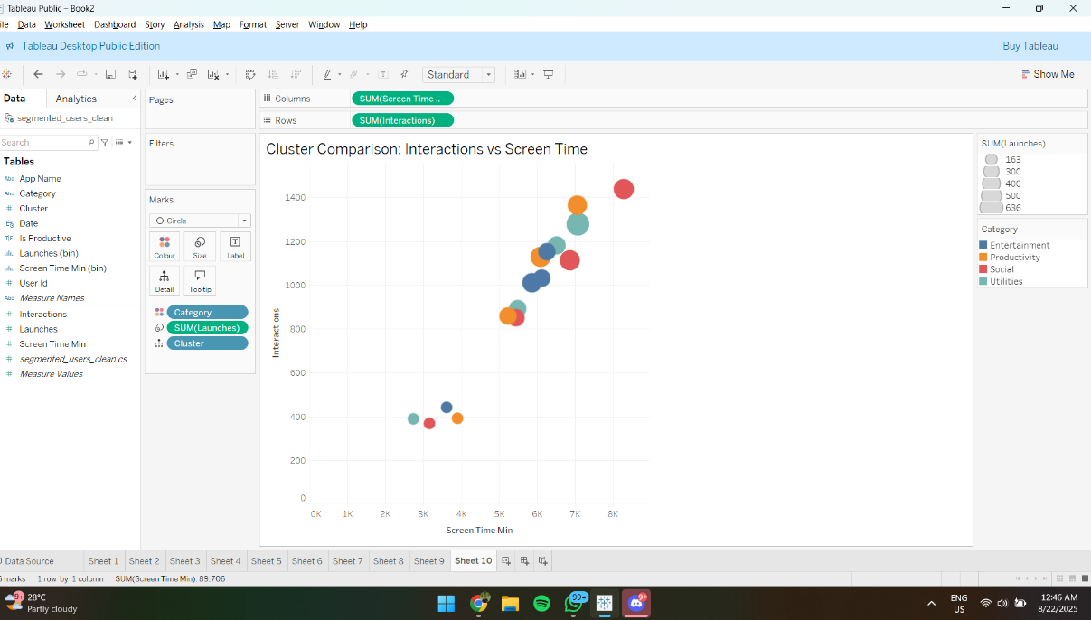
Insight: Positive correlation exists between interactions and screen time across clusters, though some groups (social users) show higher engagement with relatively lower time.
Commentary: Bubble chart design enables multi-variable comparison (time, interactions, launches). Ethical note: avoid inferring that higher engagement equates to higher value without context.

Chart 10: Top Apps by Screen Time
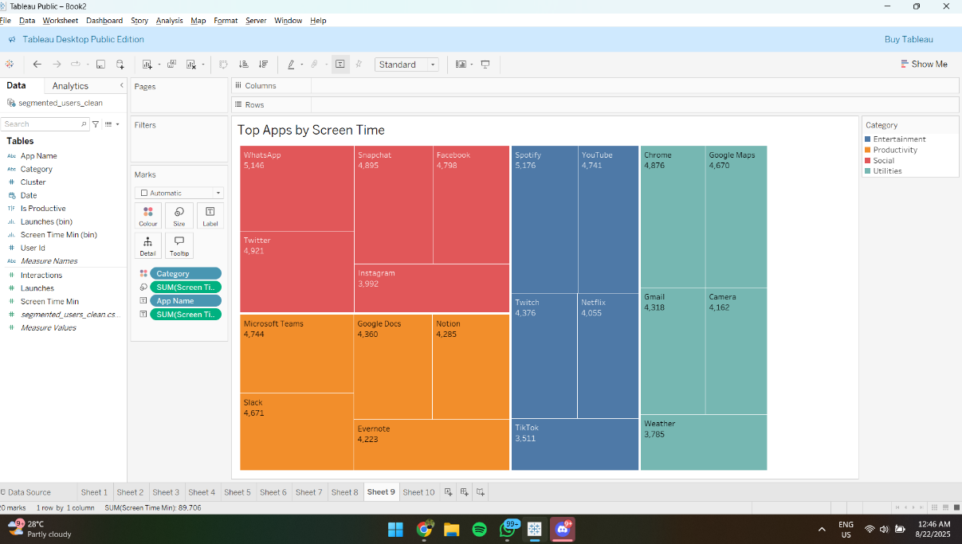
Insight: WhatsApp, Spotify, Snapchat, and Twitter are the top apps driving screen time, highlighting dominance of communication and social platforms.
Commentary: Treemap efficiently displays app-level contribution. Integrity is maintained with proportional sizing. Ethically, app-level analysis should avoid singling out users and focus on overall trends.

DASHBOARD BRIEF: USER ENGAGEMENT AND SEGMENTATION DASHBOARD

Dashboard Layout and Design Principles
The User Engagement and Segmentation Dashboard is designed to provide an intuitive, high-level view of user behavior and segmentation across app usage categories. The dashboard is split into three sections:
- Top Section: User Overview
  - Histogram (Screen Time Distribution) and Bar Chart (Avg. Screen Time by Category) provide an immediate understanding of how screen time is distributed across all users and across app categories.
- Middle Section: Segmentation and Cluster Insights
  - Scatter Plot (User Segmentation) and Bar Chart (Avg. Metrics per User Cluster) offer deep insights into the behavior of different user clusters (e.g., Socially Engaged, Productivity-focused, Entertainment-heavy).
- Bottom Section: Detailed Insights
  - Box Plot (Productive vs Non-Productive) and Bubble Chart (Cluster Comparison) provide specific insights into user engagement, comparing productive vs non-productive apps and cluster behavior by screen time and interactions.
This layout ensures that the user can easily navigate from high-level trends to detailed behavioral insights. The design follows principles of clarity, with each section visually distinct, and usability, with interactive filters to drill down into data. The dashboard supports quick decision-making, making it actionable for business users.

Clarity, Usability, and User-Centric Visualization Practices
The design prioritizes clarity and usability:
- Color Consistency: Each user segment is color-coded across charts, allowing users to quickly identify trends and behaviors across different visualizations. For example, blue represents the Socially Engaged Cluster, and green represents the Productivity-focused Cluster.
- Interactive Filters: Filters for Cluster, App Category, and Date Range allow users to customize the dashboard view to their specific interests, improving usability and reducing cognitive load.
- Simplified Visuals: By limiting the number of charts to key insights and using easy-to-understand visualizations (like bar charts, scatter plots, and treemaps), the dashboard ensures that the data is easily interpretable by users with varying levels of expertise.

Business Applicability of the Segment Insights
The insights derived from the dashboard are highly relevant for business decision-making:
- User Segmentation: Understanding Socially Engaged, Entertainment-heavy, and Productivity-focused users enables businesses to design personalized marketing campaigns and product features tailored to specific user needs.
- Engagement Insights: The Bubble Chart comparing interactions vs. screen time highlights which clusters are highly engaged. This is critical for businesses to optimize their app experience for high-engagement segments.
- Productivity Apps: The Boxplot of Productive vs Non-Productive apps reveal usage patterns of productivity apps, allowing businesses to improve features, add gamification, or incentivize usage for light productivity users.
In summary, this dashboard empowers businesses to make data-driven decisions on product enhancements, user engagement strategies, and targeted marketing campaigns by understanding how different clusters interact with apps.
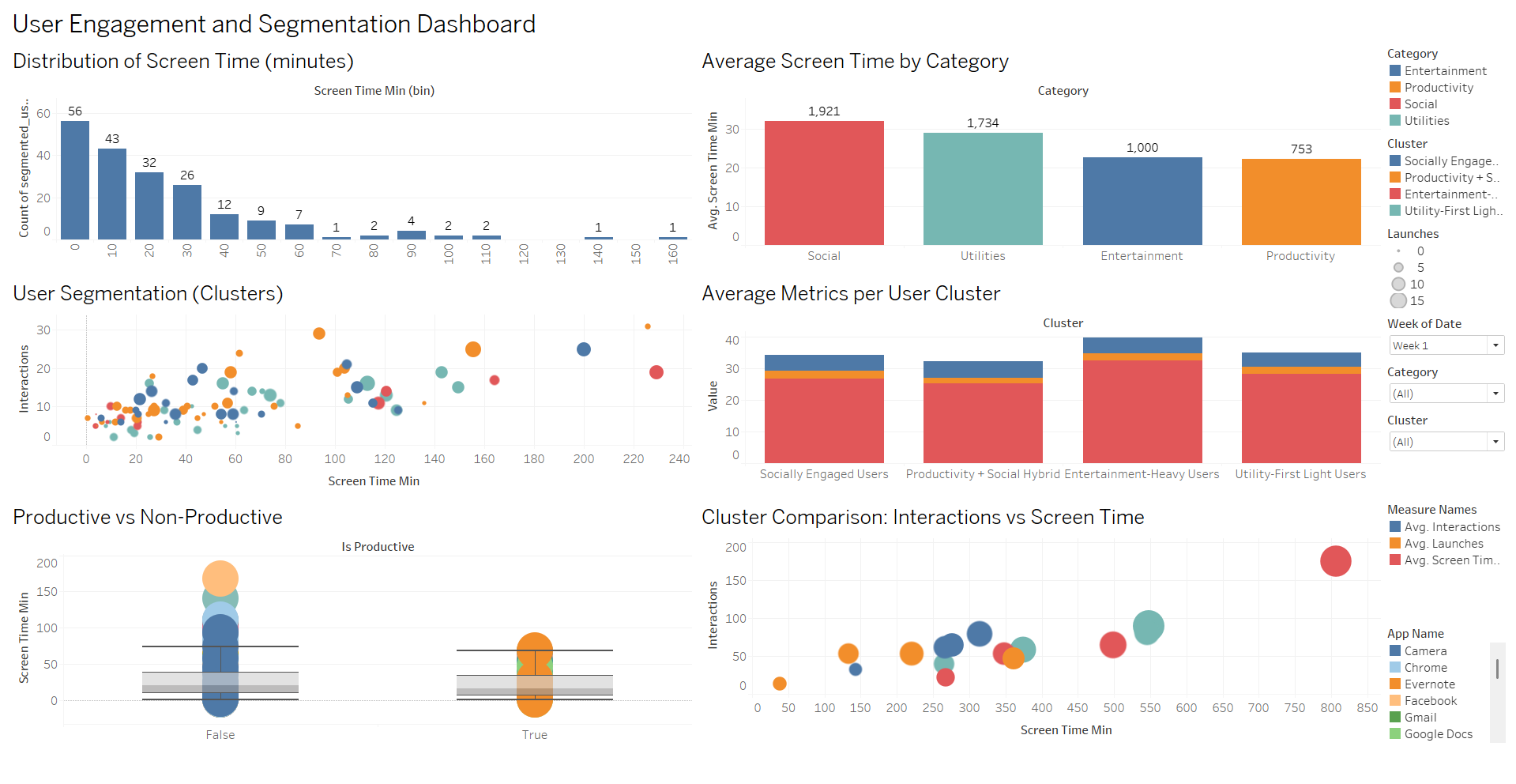

STRATEGIC APPLICATION AND RECOMMENDATIONS
Business Problem
In the highly competitive mobile app ecosystem, two major challenges dominate:
- Low user retention: Studies suggest nearly 80% of users abandon an app within the first month.
- Inefficient monetization: Not all users contribute equally to revenue, yet many platforms apply uniform strategies across their base.
When companies treat all users the same, marketing campaigns often underperform, product innovations may not resonate, and engagement levels stagnate. The key business problem therefore is:
How can app companies improve retention and revenue by tailoring strategies to distinct user segments identified through app usage behaviour?
Analytical Findings
Our k-means clustering of app usage data (variables: average screen time, launches, interactions, dominant app category) revealed four distinct user segments:
- Socially Engaged Users (~33 mins/day, highest interactions)
  - Frequent social/communication app usage.
  - High engagement and responsiveness to interactive features.
- Productivity + Social Hybrid Users (~28 mins/day, balanced use)
  - Engage with both productivity and social apps.
  - Moderate screen time and consistent activity.
- Entertainment-Heavy Users (~38 mins/day, highest screen time but passive)
  - Long sessions, low interactions (streaming, music, gaming).
  - Content consumption oriented.
- Utility-First Light Users (~27 mins/day, practical focus, low engagement)
  - Primarily functional use (utilities, tools).
  - Low screen time but frequent, task-driven launches.
These findings indicate significant behavioural diversity and clear opportunities for personalized interventions.

Segment-Based Insights and Recommendations
Using the Problem → Analysis → Insight → Action framework, we derive the following strategic applications:
a) Retention Challenge among Casual Users
- Problem: Utility-first light users and hybrids risk churn due to low engagement.
- Analysis: Limited screen time and interactions signal low stickiness.
- Insight: Lack of nudges and personalized value-added features reduces retention.
- Action:
  - Onboarding campaigns with interactive walkthroughs.
  - Smart reminders and contextual notifications.
  - Cross-promotion of utility bundles and loyalty rewards.

b) Monetization Challenge with Entertainment-Heavy Users
- Problem: Long screen time but low interactivity limits ad-based monetization.
- Analysis: Passive content consumption dominates usage behavior.
- Insight: Subscriptions and bundled content can yield more revenue than ads.
- Action:
  - Introduce personalized subscription offers (music + video + gaming).
  - Offer free trials with tiered premium upgrades.
  - Add loyalty perks such as ad-free experiences.

c) Advertising Opportunity in Socially Engaged Users
- Problem: Platforms need to grow ad-driven revenue without user fatigue.
- Analysis: This cluster has the highest interaction rate across segments.
- Insight: Socially engaged users are ideal for targeted ads and viral growth strategies.
- Action:
  - Run referral programs and social-sharing challenges.
  - Deploy interactive ad campaigns within social features.
  - Test ad frequency and formats optimized for engagement.

d) Feature Innovation for Productivity + Social Hybrid Users
- Problem: Balanced users show dual intent but lack specialized engagement drivers.
- Analysis: Consistent use across productivity and social apps indicates latent potential.
- Insight: Gamification and workflow integration could increase retention.
- Action:
  - Gamify productivity (badges, streaks, leaderboards).
  - Introduce collaborative task-sharing features.
  - Provide insights dashboards to track time/productivity progress.

Conclusion
By aligning marketing, monetization, and product strategies with segment-specific behaviours, businesses can:
- Boost retention of light/utility users through nudges and onboarding.
- Unlock premium revenues from entertainment-heavy users with subscription bundles.
- Maximize ad-driven growth from socially engaged users via interactive campaigns.
- Foster innovation for productivity-social hybrids with gamified, collaborative features.
This structured approach ensures efficient resource allocation, higher ROI, and stronger customer loyalty—highlighting the power of mobile analytics in driving data-driven decision-making.

Appendix – Python Code
A1. Importing Libraries and Dataset
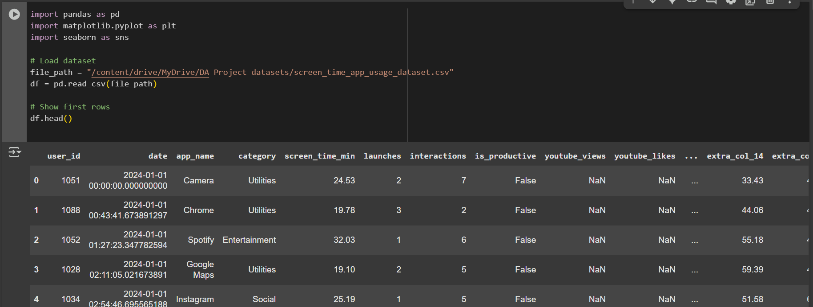

A2. Data Cleaning
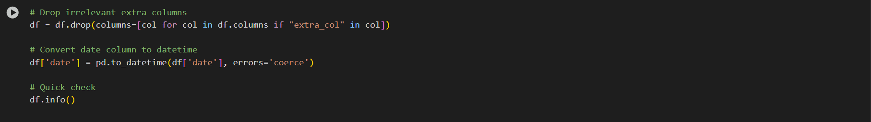

A3. Exploratory Data Analysis (EDA) 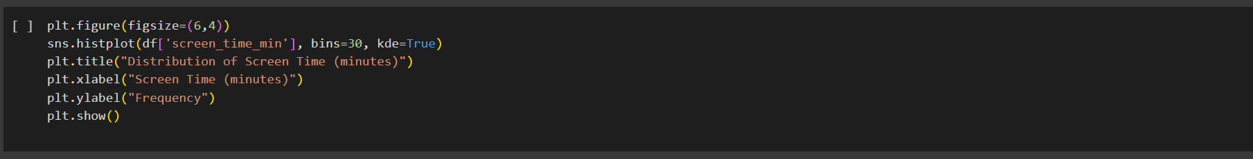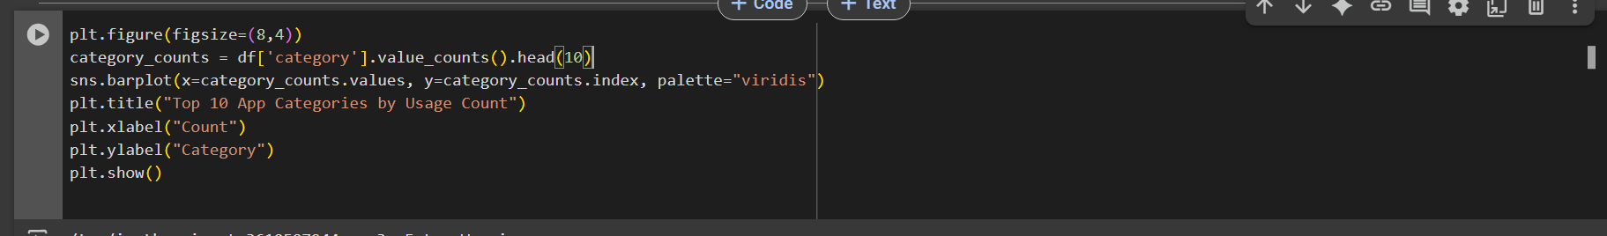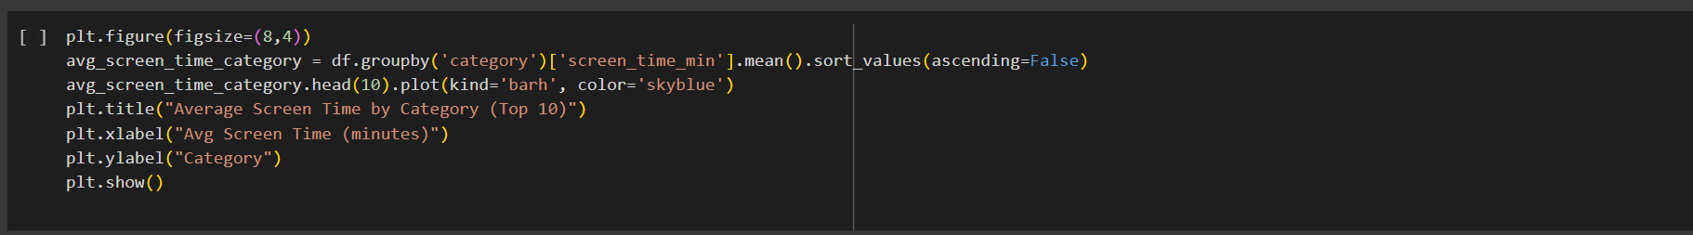

A4. User-Level Aggregation
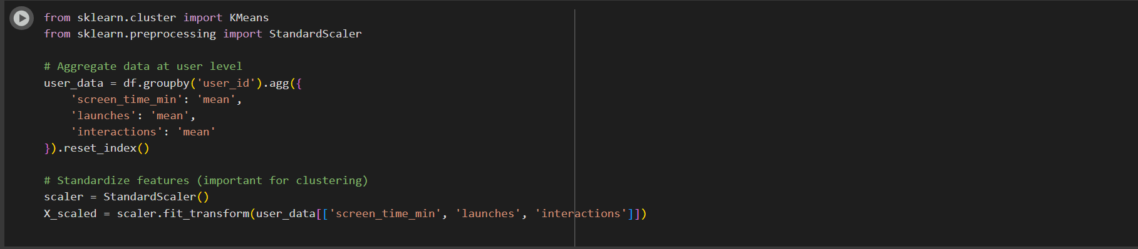

A5. K-Means Clustering
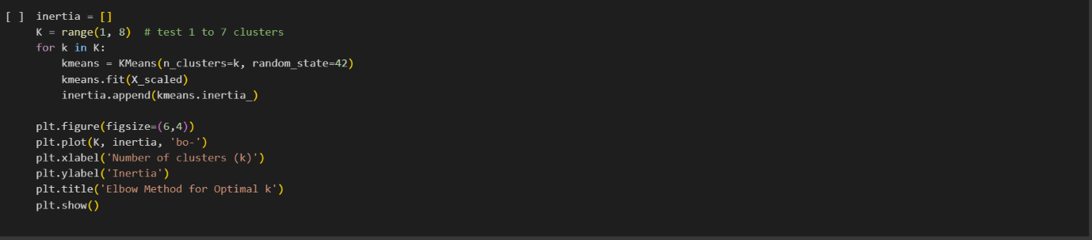
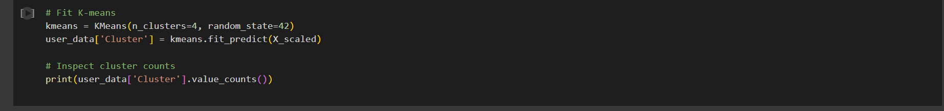
A6. Cluster Visualization
